Rockit Apple Brûlée Bites
Rockit Apple Brûlée Bites are the perfect small-format appetizer for gatherings, thanks to the naturally petite size of Rockit apples. Their crisp texture and balanced sweetness create an ideal base for a creamy whipped brie filling, a touch of crispy prosciutto, and a caramelized brûlée topping. This showstopping bite-sized dish comes together quickly using only a handful of ingredients, making it an effortless yet impressive option for entertaining.
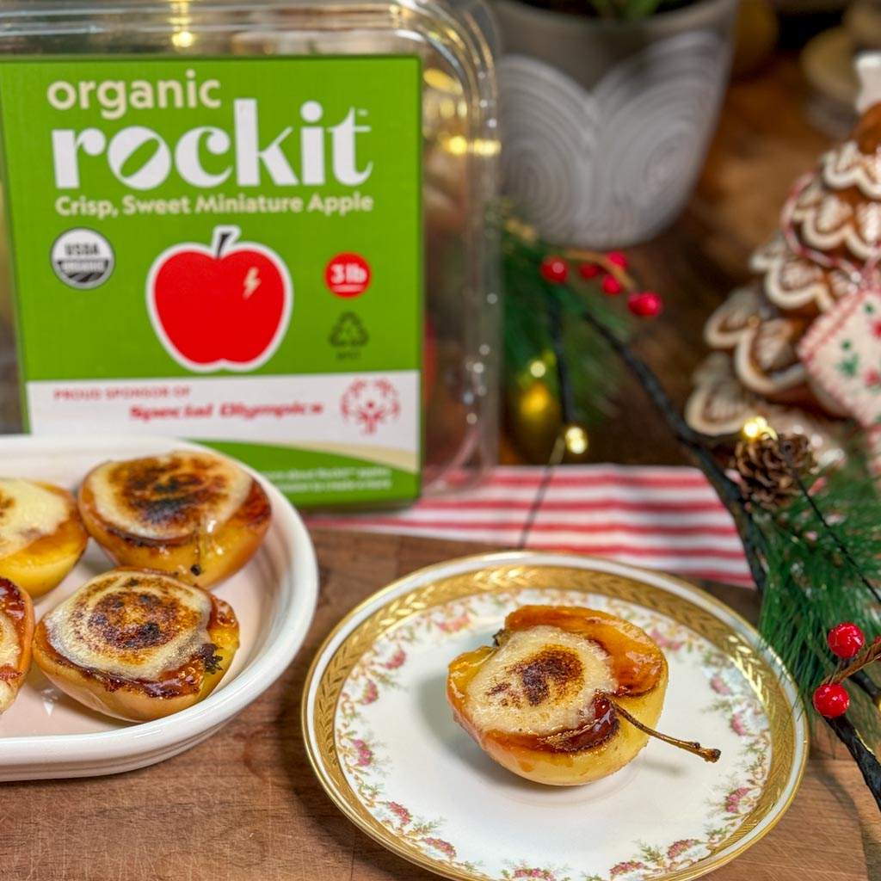

Ingredients
- 6 Rockit Apples, halved and cored with a melon baller
- 1 triangle of brie cheese (rind removed or left on, optional)
- 1/8 cup honey
- Crispy prosciutto or bacon
- 1 tablespoon butter
- Caster sugar
- Special tools: brûlée torch, piping bag

Directions
Halve the Rockit apples and remove the core using a melon baller to create a well.
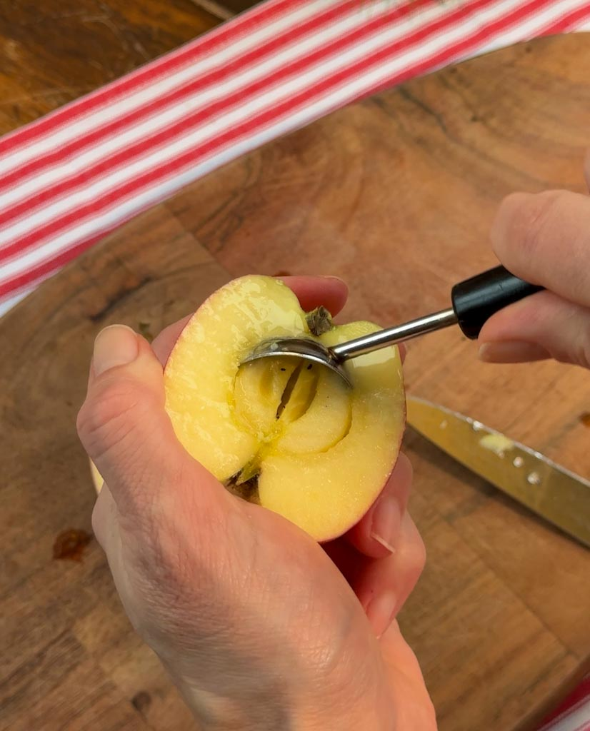
Melt one tablespoon of butter in a large pan over medium heat.
Place the Rockit apples flesh side down and allow them to brown and caramelize.
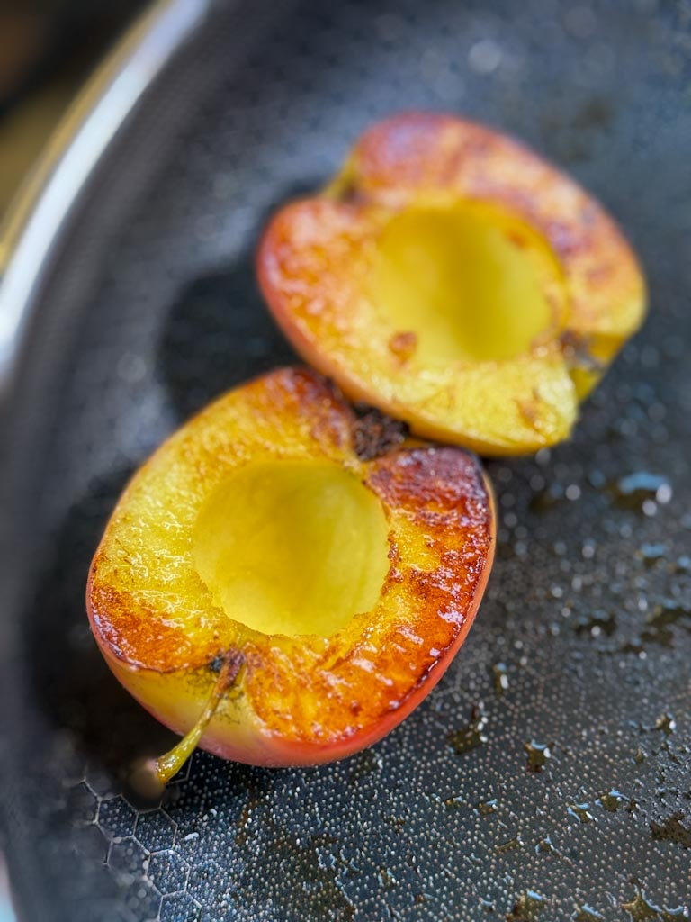
While the apples caramelize, crisp the prosciutto in a separate pan. Drain any excess fat and set aside.
Remove the apples from the pan, place them flesh side up on a serving tray, and allow them to cool.
In a food processor, whip together the brie and honey until smooth. Transfer the mixture into a piping bag (no tip necessary).
Once the apples are cool, place a pinch of crispy prosciutto into each cavity.

Pipe the whipped brie mixture into the well, filling each apple half.
Press the filled top of each apple gently into caster sugar and return to the serving tray.
Using a brûlée torch, torch the sugar until caramelized and firm.

